**Enhancement Two: Algorithms and Data Structure**

The artifact selected for this enhancement is the Travlr Getaways Travel Booking Website, originally developed during the CS465 Full Stack Development course. This project is a comprehensive web application that enables users to browse and book travel packages. It includes features for user authentication, trip management, and booking functionalities.

I chose this artifact for my ePortfolio because it demonstrates my ability to implement algorithms and efficient data structures to improve application functionality. Specifically, the enhancement involved implementing and optimizing the search functionality on the website. This showcases my skills in developing efficient algorithms that can handle fuzzy search, allowing for error tolerance in user input, such as typos. This enhancement also highlights my ability to handle and manipulate data effectively.

The key component of this enhancement is the search functionality, which was integrated into the admin side of the website to allow for more efficient trip management. The implementation involved creating a SearchService that fetches trips from the server and filters them based on the search query. The filtering algorithm is designed to handle fuzzy search, matching trips even if there are slight inaccuracies in the search input. Additionally, a SearchComponent was created to provide a user interface for the search functionality, ensuring a seamless user experience.

The primary course objective met with this enhancement is demonstrating the ability to use innovative techniques and tools in algorithms and data structures to solve real-world problems. By implementing an optimized search functionality, I have showcased my proficiency in developing and integrating efficient algorithms within a web application. This enhancement aligns with the course outcomes of designing computing solutions using best practices and managing trade-offs in design choices.

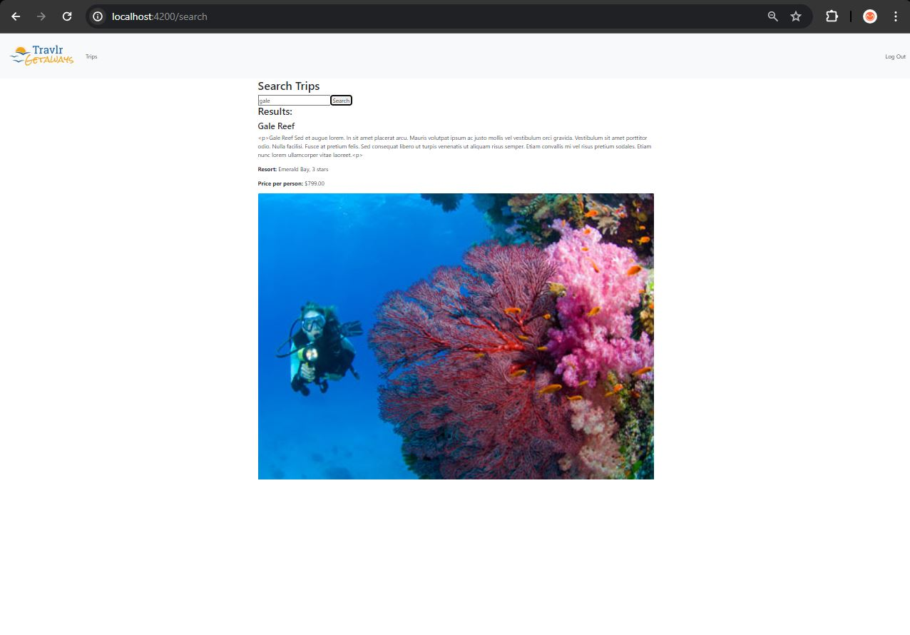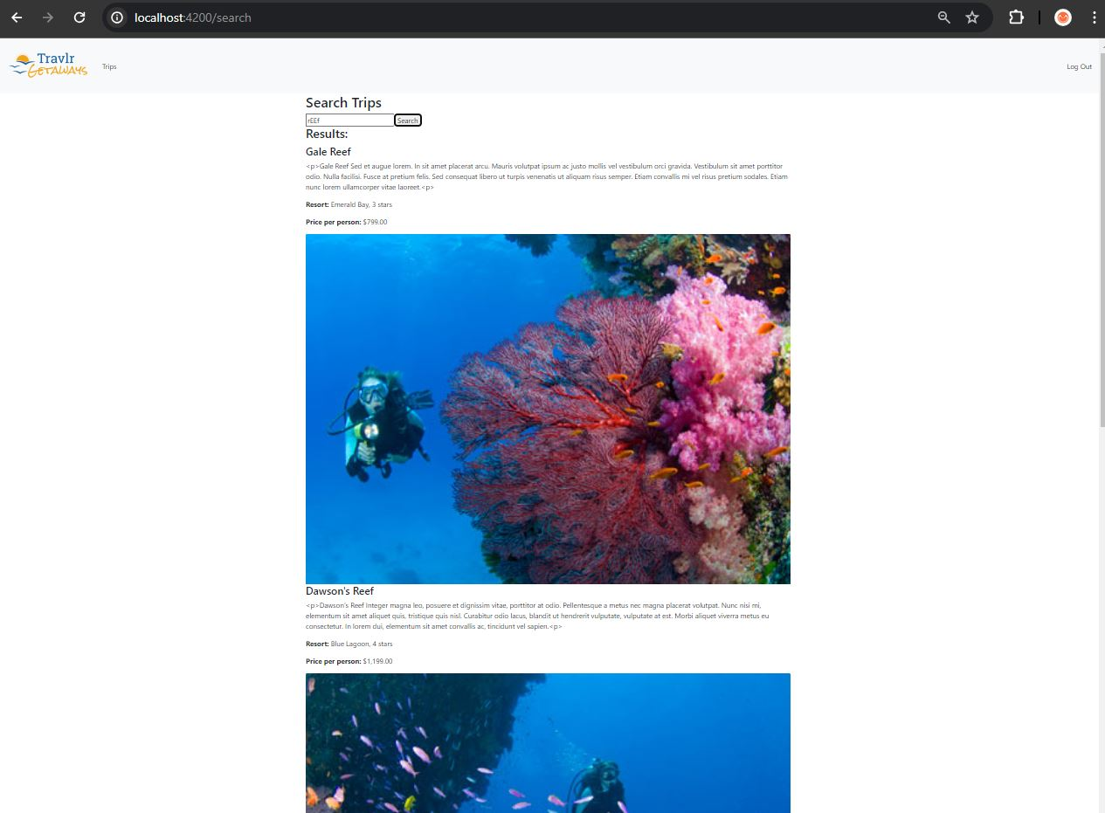The process of enhancing the search functionality was both challenging and rewarding. One of the main challenges was ensuring the search algorithm could handle fuzzy search efficiently without compromising performance. This required a solid understanding of search algorithms and optimization techniques. Throughout this enhancement, I learned the importance of algorithmic efficiency and the impact of data structures on application performance. Additionally, integrating the search functionality into the existing application required careful planning and coordination to ensure a smooth interaction with existing components and services. This enhancement not only improved the usability of the Travlr Getaways Travel Booking Website but also reinforced my skills in algorithms and data structures, showcasing my ability to implement advanced features in a scalable web application.